Coronavirus disease 2019 (COVID-19)
Situation Report – 98

Data as received by WHO from national authorities by 10:00 CEST, 27 April 2020

HIGHLIGHTS

- The WHO Regional Office for the Americas has published a document providing guidance regarding the operation of immunization programs in the context of the COVID-19 pandemic. More information is available here.

- The Ministry of Health, Consumer Affairs and Social Welfare of Spain has recently changed its criteria for reporting COVID-19 cases to include only those with positive polymerase chain reaction (PCR) test results. This has resulted in a retrospective decrease of 12,130 cases. Spain will continue to report only new PCR positive cases.

- An update on Emergency Medical Teams, the Global Health Cluster, the Global Outbreak Alert and Response Network, and Risk Communications and Community Engagement is provided in today’s ‘Subject in Focus’ below.

SITUATION IN NUMBERS
total (new cases in last 24 hours)

Globally
2 878 196 confirmed (85 530)
198 668 deaths (4982)

European Region
1 359 380 confirmed (29 659)
124 525 deaths (2307)

Region of the Americas
1 140 520 confirmed (45 674)
58 492 deaths (2453)

Eastern Mediterranean Region
165 933 confirmed (5347)
6991 deaths (104)

Western Pacific Region
144 121 confirmed (1482)
5958 deaths (15)

South-East Asia Region
46 060 confirmed (2214)
1824 deaths (77)

African Region
21 470 confirmed (1154)
865 deaths (26)

WHO RISK ASSESSMENT
Global Level Very High

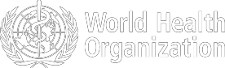

Figure 1. Countries, territories or areas with reported confirmed cases of COVID-19, 27 April 2020
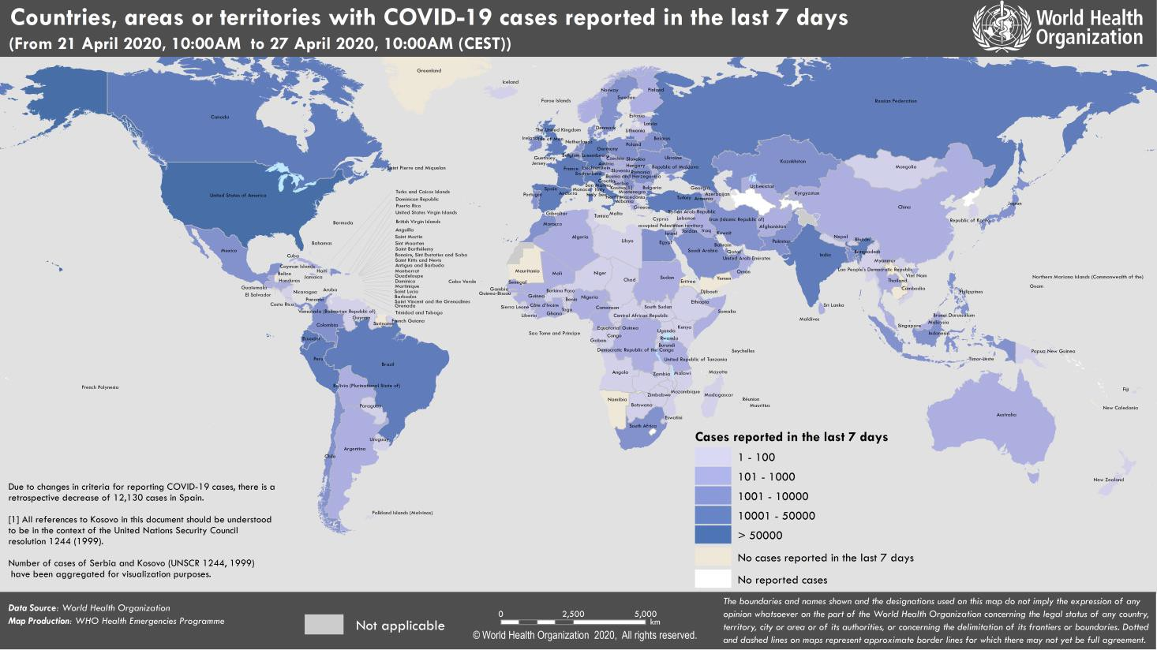

SUBJECT IN FOCUS: Partner Coordination

Emergency Medical Teams (EMTs)

- A weekly Global Coordination Call continues to be held, providing the network with updates on current operations, technical guidance, and sharing of current experiences and practices from various EMT responses to COVID-19. For current operations, the EMT Secretariat provides information on requests for global support to raise awareness and facilitate deployments of available EMTs.

- Nineteen International EMTs classified and/or in the classification process have deployed to fifteen countries across three WHO regions.

- Thirty-six EMTs are responding nationally to support and reinforce local health systems in all Regions.

- Additional deployments of Chinese EMTs are expected to Algeria, Democratic Republic of the Congo and Zimbabwe. WHO is currently working with the EMTs and countries to facilitate additional teams to Comoros and São Tomé and Príncipe.

Global Health Cluster (GHC)

- WHO and the GHC are coordinating inputs from partners on the first update of the Global Humanitarian Response Plan (GHRP) including mental health and psychosocial services, gender-based violence, protection and specific needs of older people and migrants, minimum Sphere humanitarian standards, and issues related to Water, Sanitation and Hygiene (WASH) and the Integrated Food Security Phase Classification (IPC).

- Analysis is ongoing to strengthen projections and service requirements for COVID-19 cases and wider humanitarian needs; and monitoring the impact of COVID-19 protection measures on access to essential health services.

- Reports from field locations highlight the challenges of contact tracing and sample collection in insecure areas; insufficient personal protective equipment for partners supporting health facilities; and the additional challenges of operating with staff in self-quarantine.

- GHC partners were briefed on the development of the UN COVID-19 Supply Chain Taskforce; and a webinar was held for all Health Cluster Coordinators on isolation in humanitarian settings.

- Interim Guidance on Public Health and Social Measures for COVID-19 Preparedness and Response in Low Capacity and Humanitarian Settings is under development.

Global Outbreak Alert and Response Network (GOARN)

- UNICEF, IFRC, US CDC, and OCHA continue to work closely with WHO, embedded in the global COVID-19 incident management team; and are supporting all pillars of response.

- WHO continues to facilitate direct and remote technical assistance to countries through GOARN regional and global networks to support health operations.

- A public information hub has been launched on the GOARN knowledge platform for COVID-19 to facilitate the sharing of resources by partners and other stakeholders.
- IFRC, UNICEF, and WHO with GOARN support are strengthening coordination and collaboration among key stakeholders at the global and regional levels in risk communications and community engagement (RCCE).

- With support from GOARN partners, 23 experts have been deployed or are in the process of deployment to support COVID-19 response directly or remotely. WHO is currently working with GOARN partners and EMTs to provide support in São Tomé and Príncipe, Timor-Leste, Italy, and Ecuador.

- A working group of partners has been established on contact tracing, field epidemiology, and using Go.Data to assist the urgent scale up of contact tracing capacity.

Risk Communications and Community Engagement (RCCE)

- The tripartite partnership of IFRC, UNICEF, and WHO is leading activities on Risk Communications and Community Engagement (RCCE).

- The tripartite priorities and upcoming guides, research and tools include social, cultural, and behavioural insights to guide strategies and response actions. They also provide recommendations for home care, community engagement for post-lockdown, and for low-resource settings and vulnerable populations.

- Coordination is focused on linkages between country-level RCCE efforts and broader humanitarian community engagement and coordination.

GOARN COVID-19 Research

Current activities include:

- Support to the WHO-convened COVID-19 Research Roadmap Social Science Working Group.

- Support to RCCE tripartite (WHO, UNICEF, IFRC) to identify emerging research needs that GOARN can support and disseminate findings, and support to ad hoc groups to address emerging operational issues. A repository of RCCE research and assessment tools is available on the GOARN COVID-19 Knowledge Hub.

- Rapid literature searches and evidence reviews with 24-hour turn-around. Requests are through an online portal supported by Librarian Reserve Corps. Priority is given to GOARN operational partners and WHO technical leads. These outputs are sent directly to the requester and posted on the open access GOARN COVID-19 Knowledge Hub. The Librarian Reserve Corps also curates a daily research publications list that is posted on the open access GOARN COVID-19 Knowledge Hub.

- Support for the integration of guidance, training, and tools for contact tracing for COVID-19, including communication of practitioners, and links to Field Epidemiology Training Programmes (FETPs), alumni, regional and global networks, WHO and GOARN field epidemiology partners, and stakeholders, and the Go.Data community.
SURVEILLANCE
Reporting Country/ Territory/Area† | Total  ‡  cases |  | New confirmed cases | Total deaths | New deaths | Transmission classification§ | Days since last reported case
Western Pacific Region
China |  | 84341 | 3 | 4643 | 1 | Clusters of cases | 0
Singapore |  | 13624 | 931 | 12 | 0 | Clusters of cases | 0
Japan |  | 13385 | 203 | 351 | 3 | Clusters of cases | 0
Republic of Korea |  | 10738 | 10 | 243 | 1 | Clusters of cases | 0
Philippines |  | 7579 | 285 | 501 | 7 | Clusters of cases | 0
Australia |  | 6713 | 10 | 83 | 2 | Clusters of cases | 0
Malaysia |  | 5780 | 38 | 98 | 0 | Clusters of cases | 0
New Zealand |  | 1122 | 1 | 19 | 1 | Clusters of cases | 0
Viet Nam |  | 270 | 0 | 0 | 0 | Clusters of cases | 2
Brunei Darussalam |  | 138 | 0 | 1 | 0 | Sporadic cases | 7
Cambodia |  | 122 | 0 | 0 | 0 | Sporadic cases | 15
Mongolia |  | 38 | 1 | 0 | 0 | Sporadic cases | 0
Lao People's Democratic Republic |  | 19 | 0 | 0 | 0 | Sporadic cases | 14
Fiji |  | 18 | 0 | 0 | 0 | Sporadic cases | 6
Papua New Guinea |  | 8 | 0 | 0 | 0 | Sporadic cases | 4
Territories**
Guam |  | 137 | 0 | 5 | 0 | Clusters of cases | 1
French Polynesia |  | 57 | 0 | 0 | 0 | Sporadic cases | 5
New Caledonia |  | 18 | 0 | 0 | 0 | Sporadic cases | 24
Northern Mariana Islands (Common- wealth of the) |  | 14 | 0 | 2 | 0 | Pending | 9
European Region
Spain |  | 207634 | 0 | 23190 | 666 | Pending | 0
Italy |  | 197675 | 2324 | 26644 | 260 | Community transmission | 0
Germany |  | 155193 | 1018 | 5750 | 110 | Community transmission | 0
The United Kingdom |  | 152844 | 4463 | 20732 | 413 | Community transmission | 0
France |  | 123279 | 404 | 22821 | 241 | Community transmission | 0
Turkey |  | 110130 | 2357 | 2805 | 99 | Community transmission | 0
Russian Federation |  | 87147 | 12559 | 794 | 113 | Clusters of cases | 0
Belgium |  | 46134 | 809 | 7094 | 177 | Community transmission | 0
Netherlands |  | 37845 | 655 | 4475 | 66 | Community transmission | 0
Switzerland |  | 28978 | 0 | 1336 | 0 | Community transmission | 1

Table 1. Countries, territories or areas with reported laboratory-confirmed COVID-19 cases and deaths, by WHO region. * Data as of 27 April 2020

confirmed

Portugal | 23864 | 472 | 903 | 23 | Pending | 0
Ireland | 19262 | 701 | 1087 | 24 | Community transmission | 0
Sweden | 18640 | 463 | 2194 | 2 | Community transmission | 0
Israel | 15398 | 0 | 199 | 0 | Pending | 1
Austria | 15189 | 55 | 542 | 6 | Community transmission | 0
Poland | 11617 | 344 | 535 | 11 | Pending | 0
Romania | 11036 | 401 | 608 | 33 | Community transmission | 0
Belarus | 10463 | 873 | 72 | 5 | Clusters of cases | 0
Ukraine | 9009 | 392 | 220 | 11 | Community transmission | 0
Denmark | 8575 | 130 | 422 | 4 | Pending | 0
Serbia | 8042 | 263 | 156 | 5 | Pending | 0
Norway | 7505 | 38 | 193 | 0 | Pending | 0
Czechia | 7404 | 52 | 221 | 3 | Community transmission | 0
Finland | 4576 | 101 | 190 | 4 | Pending | 0
Luxembourg | 3723 | 12 | 88 | 3 | Pending | 0
Republic of Moldova | 3408 | 104 | 96 | 2 | Pending | 0
Kazakhstan | 2791 | 190 | 25 | 0 | Pending | 0
Hungary | 2583 | 83 | 280 | 8 | Clusters of cases | 0
Greece | 2506 | 0 | 130 | 0 | Community transmission | 1
Croatia | 2030 | 14 | 55 | 1 | Community transmission | 0
Uzbekistan | 1887 | 22 | 8 | 0 | Clusters of cases | 0
Armenia | 1808 | 62 | 29 | 1 | Clusters of cases | 0
Iceland | 1792 | 2 | 10 | 0 | Community transmission | 0
Azerbaijan | 1645 | 28 | 21 | 0 | Clusters of cases | 0
Estonia | 1643 | 8 | 49 | 3 | Pending | 0
Bosnia and Herzegovina | 1516 | 31 | 58 | 2 | Community transmission | 0
Lithuania | 1449 | 11 | 41 | 0 | Community transmission | 0
Slovenia | 1407 | 19 | 82 | 1 | Community transmission | 0
North Macedonia | 1386 | 19 | 61 | 2 | Clusters of cases | 0
Slovakia | 1379 | 6 | 18 | 1 | Clusters of cases | 0
Bulgaria | 1300 | 53 | 56 | 1 | Pending | 0
Cyprus | 817 | 7 | 17 | 0 | Clusters of cases | 0
Latvia | 812 | 8 | 12 | 0 | Pending | 0
Andorra | 740 | 2 | 40 | 0 | Community transmission | 0
Albania | 726 | 14 | 28 | 1 | Clusters of cases | 0
Kyrgyzstan | 695 | 13 | 8 | 0 | Pending | 0
San Marino | 538 | 25 | 41 | 1 | Community transmission | 0

Georgia | 496 | 11 | 6 | 1 | Community transmission | 0
Malta | 448 | 0 | 4 | 0 | Pending | 1
Montenegro | 321 | 2 | 7 | 1 | Clusters of cases | 0
Liechtenstein | 83 | 0 | 1 | 0 | Pending | 1
Monaco | 68 | 0 | 1 | 0 | Sporadic cases | 13
Holy See | 9 | 0 | 0 | 0 | Sporadic cases | 6
Territories**
Kosovo[1] | 763 | 32 | 21 | 1 | Community transmission | 0
Isle of Man | 308 | 0 | 18 | 0 | Pending | 2
Jersey | 280 | 2 | 19 | 0 | Pending | 0
Guernsey | 245 | 0 | 12 | 1 | Community transmission | 2
Faroe Islands | 187 | 0 | 0 | 0 | Pending | 3
Gibraltar | 141 | 5 | 0 | 0 | Clusters of cases | 0
Greenland | 11 | 0 | 0 | 0 | Pending | 21
South-East Asia Region
India | 27892 | 1396 | 872 | 48 | Clusters of cases | 0
Indonesia | 8882 | 275 | 743 | 23 | Community transmission | 0
Bangladesh | 5416 | 418 | 145 | 5 | Pending | 0
Thailand | 2931 | 9 | 52 | 1 | Pending | 0
Sri Lanka | 523 | 63 | 7 | 0 | Clusters of cases | 0
Maldives | 188 | 51 | 0 | 0 | Clusters of cases | 0
Myanmar | 146 | 0 | 5 | 0 | Clusters of cases | 1
Nepal | 51 | 2 | 0 | 0 | Sporadic cases | 0
Timor-Leste | 24 | 0 | 0 | 0 | Clusters of cases | 3
Bhutan | 7 | 0 | 0 | 0 | Sporadic cases | 4
Eastern Mediterranean Region
Iran (Islamic Republic of) | 90481 | 1153 | 5710 | 60 | Community transmission | 0
Saudi Arabia | 17522 | 1223 | 139 | 3 | Clusters of cases | 0
Pakistan | 13328 | 605 | 281 | 12 | Clusters of cases | 0
United Arab Emirates | 10349 | 536 | 76 | 5 | Pending | 0
Qatar | 10287 | 929 | 10 | 0 | Pending | 0
Egypt | 4534 | 215 | 317 | 10 | Clusters of cases | 0
Morocco | 4065 | 168 | 161 | 2 | Clusters of cases | 0
Kuwait | 3075 | 183 | 20 | 1 | Clusters of cases | 0
Bahrain | 2647 | 58 | 8 | 0 | Clusters of cases | 0
Oman | 2049 | 51 | 10 | 0 | Clusters of cases | 0
Iraq | 1820 | 57 | 87 | 1 | Clusters of cases | 0
Afghanistan | 1531 | 68 | 50 | 1 | Clusters of cases | 0
Djibouti | 1023 | 15 | 2 | 0 | Clusters of cases | 0
Tunisia | 949 | 10 | 38 | 0 | Community transmission | 0
Lebanon | 707 | 3 | 24 | 0 | Clusters of cases | 0
Jordan | 447 | 3 | 7 | 0 | Clusters of cases | 0
Somalia | 436 | 46 | 23 | 5 | Sporadic cases | 0
Sudan | 237 | 24 | 21 | 4 | Sporadic cases | 0

Libya | 61 | 0 | 2 | 0 | Clusters of cases | 2
Syrian Arab Republic | 42 | 0 | 3 | 0 | Community transmission | 5
Yemen | 1 | 0 | 0 | 0 | Pending | 16
Territories**
occupied Palestinian territory | 342 | 0 | 2 | 0 | Clusters of cases | 1
Region of the Americas
United States of America | 931698 | 32417 | 47980 | 1776 | Community transmission | 0
Brazil | 58509 | 5514 | 4016 | 346 | Community transmission | 0
Canada | 45778 | 1425 | 2489 | 139 | Community transmission | 0
Peru | 25331 | 3683 | 700 | 66 | Community transmission | 0
Ecuador | 22719 | 0 | 576 | 0 | Community transmission | 2
Mexico | 13842 | 970 | 1305 | 84 | Community transmission | 0
Chile | 13331 | 473 | 189 | 8 | Community transmission | 0
Dominican Republic | 6135 | 209 | 278 | 5 | Community transmission | 0
Panama | 5538 | 200 | 159 | 5 | Community transmission | 0
Colombia | 5142 | 261 | 233 | 8 | Community transmission | 0
Argentina | 3838 | 137 | 179 | 0 | Community transmission | 0
Cuba | 1369 | 32 | 54 | 3 | Clusters of cases | 0
Bolivia (Plurinational State of) | 866 | 59 | 46 | 2 | Clusters of cases | 0
Costa Rica | 693 | 6 | 6 | 0 | Clusters of cases | 0
Honduras | 627 | 36 | 59 | 4 | Clusters of cases | 0
Uruguay | 596 | 33 | 14 | 2 | Clusters of cases | 0
Guatemala | 473 | 43 | 15 | 2 | Clusters of cases | 0
Venezuela (Bolivarian Republic of) | 323 | 5 | 10 | 0 | Clusters of cases | 0
Jamaica | 305 | 17 | 7 | 0 | Clusters of cases | 0
El Salvador | 298 | 24 | 8 | 0 | Clusters of cases | 0
Paraguay | 228 | 5 | 9 | 0 | Community transmission | 0
Trinidad and Tobago | 115 | 0 | 8 | 0 | Sporadic cases | 4
Barbados | 79 | 2 | 6 | 0 | Clusters of cases | 0
Bahamas | 78 | 6 | 11 | 0 | Clusters of cases | 0
Guyana | 74 | 1 | 8 | 1 | Clusters of cases | 0
Haiti | 72 | 0 | 6 | 0 | Clusters of cases | 2
Antigua and Barbuda | 24 | 0 | 3 | 0 | Clusters of cases | 4
Belize | 18 | 0 | 2 | 0 | Sporadic cases | 12
Grenada | 18 | 3 | 0 | 0 | Clusters of cases | 0
Dominica | 16 | 0 | 0 | 0 | Clusters of cases | 16
Saint Kitts and Nevis | 15 | 0 | 0 | 0 | Sporadic cases | 6

Saint Lucia | 15 | 0 | 0 | 0 | Sporadic cases | 15
Saint Vincent and the Grenadines | 14 | 0 | 0 | 0 | Sporadic cases | 2
Nicaragua | 13 | 2 | 3 | 0 | Pending | 0
Suriname | 10 | 0 | 1 | 0 | Sporadic cases | 23
Territories**
Puerto Rico | 1371 | 95 | 53 | 0 | Clusters of cases | 0
Martinique | 175 | 5 | 14 | 0 | Clusters of cases | 0
Guadeloupe | 149 | 0 | 13 | 1 | Clusters of cases | 2
Bermuda | 109 | 10 | 5 | 0 | Clusters of cases | 0
French Guiana | 109 | 0 | 1 | 0 | Clusters of cases | 2
Aruba | 100 | 0 | 2 | 0 | Clusters of cases | 4
Sint Maarten | 74 | 1 | 13 | 1 | Clusters of cases | 0
Cayman Islands | 70 | 0 | 1 | 0 | Clusters of cases | 1
United States Virgin Islands | 55 | 0 | 3 | 0 | Clusters of cases | 1
Saint Martin | 38 | 0 | 3 | 0 | Sporadic cases | 4
Curaçao | 14 | 0 | 1 | 0 | Sporadic cases | 18
Falkland Islands (Malvinas) | 13 | 0 | 0 | 0 | Clusters of cases | 1
Montserrat | 11 | 0 | 1 | 0 | Sporadic cases | 13
Turks and Caicos Islands | 11 | 0 | 1 | 0 | Sporadic cases | 10
British Virgin Islands | 6 | 0 | 1 | 0 | Sporadic cases | 1
Saint Barthélemy | 6 | 0 | 0 | 0 | Sporadic cases | 27
Bonaire, Sint Eustatius and Saba | 5 | 0 | 0 | 0 | Sporadic cases | 9
Anguilla | 3 | 0 | 0 | 0 | Sporadic cases | 23
Saint Pierre and Miquelon | 1 | 0 | 0 | 0 | Sporadic cases | 19
African Region
South Africa | 4546 | 185 | 87 | 1 | Community transmission | 0
Algeria | 3382 | 126 | 425 | 6 | Community transmission | 0
Cameroon | 1621 | 103 | 56 | 3 | Clusters of cases | 0
Ghana | 1550 | 271 | 11 | 1 | Clusters of cases | 0
Nigeria | 1273 | 91 | 40 | 5 | Community transmission | 0
Côte d’Ivoire | 1150 | 39 | 14 | 0 | Clusters of cases | 0
Guinea | 1094 | 98 | 7 | 0 | Community transmission | 0
Niger | 696 | 12 | 29 | 2 | Clusters of cases | 0
Senegal | 671 | 57 | 9 | 2 | Clusters of cases | 0
Burkina Faso | 632 | 3 | 42 | 1 | Community transmission | 0
Democratic Republic of the Congo | 459 | 17 | 28 | 0 | Clusters of cases | 0
Mali | 389 | 19 | 23 | 2 | Clusters of cases | 0
Kenya | 355 | 12 | 14 | 0 | Clusters of cases | 0
Mauritius | 332 | 1 | 9 | 0 | Community transmission | 0

United Republic of Tanzania | 300 | 0 | 10 | 0 | Clusters of cases | 2
Equatorial Guinea | 258 | 0 | 1 | 0 | Clusters of cases | 1
Congo | 200 | 0 | 8 | 0 | Clusters of cases | 2
Rwanda | 191 | 8 | 0 | 0 | Clusters of cases | 0
Gabon | 176 | 0 | 3 | 0 | Clusters of cases | 1
Madagascar | 128 | 4 | 0 | 0 | Clusters of cases | 0
Liberia | 124 | 4 | 12 | 1 | Clusters of cases | 0
Ethiopia | 123 | 1 | 3 | 0 | Clusters of cases | 0
Cabo Verde | 106 | 16 | 1 | 0 | Sporadic cases | 0
Togo | 98 | 2 | 6 | 0 | Clusters of cases | 0
Sierra Leone | 93 | 7 | 4 | 1 | Clusters of cases | 0
Zambia | 88 | 4 | 3 | 0 | Sporadic cases | 0
Mozambique | 76 | 6 | 0 | 0 | Sporadic cases | 0
Uganda | 75 | 0 | 0 | 0 | Sporadic cases | 2
Benin | 64 | 6 | 1 | 0 | Sporadic cases | 0
Eswatini | 59 | 3 | 1 | 0 | Sporadic cases | 0
Guinea-Bissau | 53 | 1 | 1 | 1 | Sporadic cases | 0
Chad | 46 | 0 | 0 | 0 | Sporadic cases | 1
Eritrea | 39 | 0 | 0 | 0 | Sporadic cases | 8
Malawi | 34 | 1 | 3 | 0 | Sporadic cases | 0
Zimbabwe | 31 | 0 | 4 | 0 | Sporadic cases | 1
Angola | 26 | 1 | 2 | 0 | Sporadic cases | 0
Botswana | 22 | 0 | 1 | 0 | Sporadic cases | 4
Central African Republic | 19 | 0 | 0 | 0 | Sporadic cases | 2
Namibia | 16 | 0 | 0 | 0 | Sporadic cases | 21
Burundi | 15 | 3 | 1 | 0 | Sporadic cases | 0
Seychelles | 11 | 0 | 0 | 0 | Sporadic cases | 20
Gambia | 10 | 0 | 1 | 0 | Sporadic cases | 6
São Tomé and Príncipe | 8 | 0 | 0 | 0 | Sporadic cases | 3
Mauritania | 7 | 0 | 1 | 0 | Sporadic cases | 16
South Sudan | 6 | 1 | 0 | 0 | Sporadic cases | 0
Territories**
Réunion | 417 | 5 | 0 | 0 | Clusters of cases | 0
Mayotte | 401 | 47 | 4 | 0 | Clusters of cases | 0
Subtotal for all Regions | 2877484 | 85530 | 198655 | 4982
International conveyance (Diamond Princess) | 712 | 0 | 13 | 0 | Not Applicable†† | 42
Grand total | 2878196 | 85530 | 198668 | 4982
*Countries are arranged by official WHO regions, in descending order by the number of total confirmed cases. Overseas territories** are listed under the WHO region that administers them.
†The designations employed and the presentation of the material in this publication do not imply the expression of any opinion whatsoever on the part of WHO concerning the legal status of any country, territory, city or area or of its authorities, or concerning the delimitation of its frontiers or boundaries. Dotted and dashed lines on maps represent approximate border lines for which there may not yet be full agreement.
‡Case classifications are based on WHO case definitions for COVID-19.
§Transmission classification is based on a process of country/territory/area self-reporting. Classifications are reviewed on a weekly basis and may be upgraded or downgraded as new information becomes available. Not all locations within a given country/territory/area are equally affected; countries/territories/areas experiencing multiple types of transmission are classified in the highest category reported. Within a given transmission category, different countries/territories/areas may have differing degrees of transmission as indicated by the differing numbers of
cases, recency of cases, and other factors. Terms:
- No cases: Countries/territories/areas with no confirmed cases (not shown in table)
- Sporadic cases: Countries/territories/areas with one or more cases, imported or locally detected
- Clusters of cases: Countries/territories/areas experiencing cases, clustered in time, geographic location and/or by common exposures
- Community transmission: Countries/area/territories experiencing larger outbreaks of local transmission defined through an assessment of factors including, but not limited to:
  - Large numbers of cases not linkable to transmission chains
  - Large numbers of cases from sentinel lab surveillance
  - Multiple unrelated clusters in several areas of the country/territory/area

** “Territories” include territories, areas, overseas dependencies and other jurisdictions of similar status
[1] All references to Kosovo should be understood to be in the context of the United Nations Security Council resolution 1244 (1999).
†† As the international conveyance (Diamond Princess) is no longer occupied, transmission classification cannot be applied.

Due to differences in reporting methods, retrospective data consolidation, and reporting delays, the number of new cases may not always reflect the exact difference between yesterday’s and today’s totals. WHO COVID-19 Situation Reports present official counts of confirmed COVID-19 cases, thus differences between WHO reports and other sources of COVID-19 data using different inclusion criteria and different data cutoff times are to be expected.

Figure 2. Epidemic curve of confirmed COVID-19, by date of report and WHO region through 27 April 2020

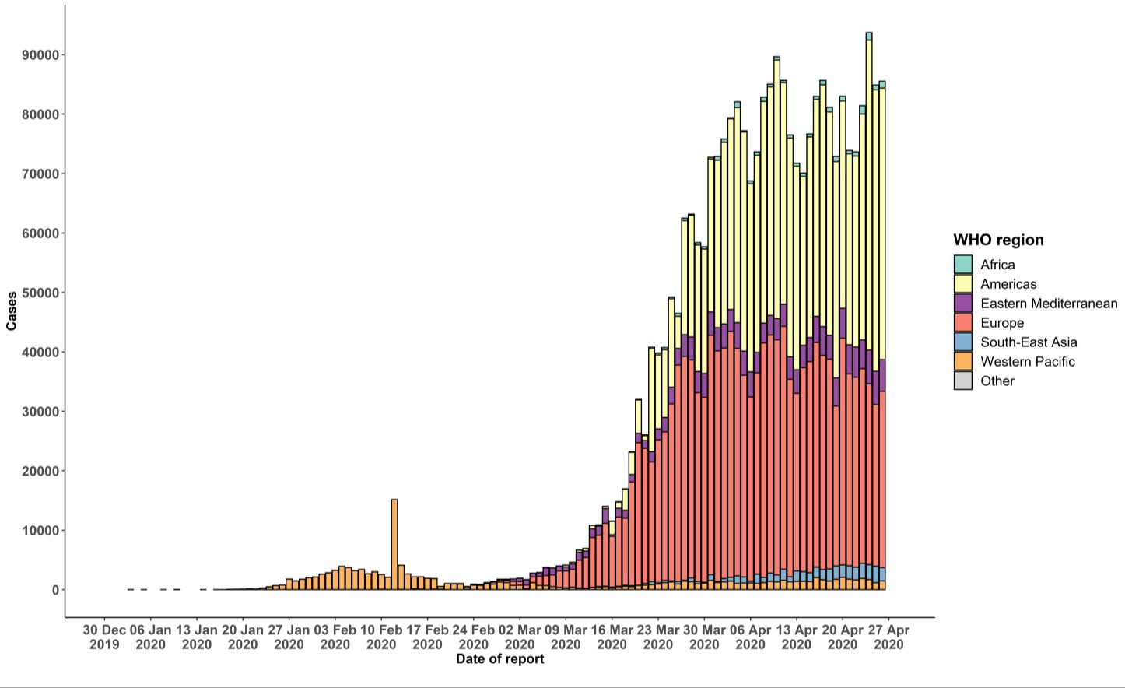

Note: Numbers in the epidemic curve have not been adjusted to reflect the data reconciliation in Spain, pending further expected reconciliation.
STRATEGIC OBJECTIVES

WHO’s strategic objectives for this response are to:

- Interrupt human-to-human transmission including reducing secondary infections among close contacts and health care workers, preventing transmission amplification events, and preventing further international spread*;
- Identify, isolate and care for patients early, including providing optimized care for infected patients;
- Identify and reduce transmission from the animal source;
- Address crucial unknowns regarding clinical severity, extent of transmission and infection, treatment options, and accelerate the development of diagnostics, therapeutics and vaccines;
- Communicate critical risk and event information to all communities and counter misinformation;
- Minimize social and economic impact through multisectoral partnerships.

*This can be achieved through a combination of public health measures, such as rapid identification, diagnosis and management of the cases, identification and follow up of the contacts, infection prevention and control in health care settings, implementation of health measures for travelers, awareness-raising in the population and risk communication.

PREPAREDNESS AND RESPONSE
- To view all technical guidance documents regarding COVID-19, please go to this webpage.
- WHO has developed interim guidance for laboratory diagnosis, advice on the use of masks during home care and in health care settings in the context of COVID-19 outbreak, clinical management, infection prevention and control in health care settings, home care for patients with suspected novel coronavirus, risk communication and community engagement and Global Surveillance for human infection with COVID-19.
- WHO is working closely with International Air Transport Association (IATA) and have jointly developed a guidance document to provide advice to cabin crew and airport workers, based on country queries. The guidance can be found on the IATA webpage.
- WHO has been in regular and direct contact with Member States where cases have been reported. WHO is also informing other countries about the situation and providing support as requested.
- WHO is working with its networks of researchers and other experts to coordinate global work on surveillance, epidemiology, mathematical modelling, diagnostics and virology, clinical care and treatment, infection prevention and control, and risk communication. WHO has issued interim guidance for countries, which are updated regularly.
- WHO has prepared a disease commodity package that includes an essential list of biomedical equipment, medicines and supplies necessary to care for patients with COVID-19.
- WHO has provided recommendations to reduce risk of transmission from animals to humans.
- WHO has published an updated recommendations for international traffic in relation to COVID-19 outbreak .
- WHO has activated the R&D blueprint to accelerate diagnostics, vaccines, and therapeutics.
- OpenWHO is an interactive, web-based, knowledge-transfer platform offering free online courses to improve the response to health emergencies. COVID-19 resources are hosted on 2 learning channels: one for courses in official WHO languages here and a second for courses in additional national languages here.
  - There are more than 1.5 million enrolments in the platform's courses to support the COVID-19 response. Specifically, WHO has developed courses on the following topics:
  - A general introduction to emerging respiratory viruses, including novel coronaviruses (available
in Arabic, Chinese, English, French, Russian, Spanish, Bengali, Hindi, Hungarian, Indian Sign Language, Indonesian, Macedonian, Persian, Portuguese, Serbian, Turkish and Vietnamese);
  - Clinical care for Severe Acute Respiratory Infection (SARI) (available in English, French, Russian, Spanish, Indonesian, Portuguese and Vietnamese);
  - Health and safety briefing for respiratory diseases – ePROTECT (available in Arabic, Chinese, English, French, Russian, Spanish, Indonesian and Portuguese);
  - Infection Prevention and Control for COVID-19 (available
in Chinese, English, French, Russian, Spanish, Indonesian, Italian, Japanese, Macedonian, Portuguese, Ser bian and Turkish);
  - COVID-19 operational planning guidelines and partners platform to support country preparedness and response (available in Chinese, English, French, Russian, Indonesian and Portuguese);
  - SARI treatment facility design (available in Arabic, English, Italian and Portuguese);
  - An introduction to Go.Data – field data collection, chains of transmission and contact follow-up (available in English and coming soon in additional languages);
  - How to put on and remove personal protective equipment (PPE) for COVID-19 (available in English and coming soon in additional languages); and
  - Standard precautions for hand hygiene (available in English and coming soon in additional languages).
- WHO is providing guidance on early investigations, which are critical in an outbreak of a new virus. The data collected from the protocols can be used to refine recommendations for surveillance and case definitions, to characterize the key epidemiological transmission features of COVID-19, help understand spread, severity, spectrum of disease, impact on the community and to inform operational models for implementation of countermeasures such as case isolation, contact tracing and isolation. Several protocols are available here. One such protocol is for the investigation of early COVID-19 cases and contacts (the “First Few X (FFX) Cases and contact investigation protocol for 2019-novel coronavirus (2019-nCoV) infection”). The protocol is designed to gain an early understanding of the key clinical, epidemiological and virological characteristics of the first cases of COVID-19 infection detected in any individual country, to inform the development and updating of public health guidance to manage cases and reduce the potential spread and impact of infection.

RECOMMENDATIONS AND ADVICE FOR THE PUBLIC

If you are not in an area where COVID-19 is spreading or have not travelled from an area where COVID-19 is spreading or have not been in contact with an infected patient, your risk of infection is low. It is understandable that you may feel anxious about the outbreak. Get the facts from reliable sources to help you accurately determine your risks so that you can take reasonable precautions (see Frequently Asked Questions). Seek guidance from WHO, your healthcare provider, your national public health authority or your employer for accurate information on COVID-19 and whether COVID-19 is circulating where you live. It is important to be informed of the situation and take appropriate measures to protect yourself and your family (see Protection measures for everyone).

If you are in an area where there are cases of COVID-19 you need to take the risk of infection seriously. Follow the advice of WHO and guidance issued by national and local health authorities. For most people, COVID-19 infection will cause mild illness however, it can make some people very ill and, in some people, it can be fatal. Older people, and those with pre-existing medical conditions (such as cardiovascular disease, chronic respiratory disease or diabetes) are at risk for severe disease (See Protection measures for persons who are in or have recently visited (past 14 days) areas where COVID-19 is spreading).

CASE DEFINITIONS

WHO periodically updates the Global Surveillance for human infection with coronavirus disease (COVID-19) document which includes case definitions.

For easy reference, case definitions are included below.
Suspect case
- A patient with acute respiratory illness (fever and at least one sign/symptom of respiratory disease, e.g., cough, shortness of breath), AND a history of travel to or residence in a location reporting community transmission of COVID-19 disease during the 14 days prior to symptom onset.
OR
- A patient with any acute respiratory illness AND having been in contact with a confirmed or probable COVID-19 case (see definition of contact) in the last 14 days prior to symptom onset;
OR
- A patient with severe acute respiratory illness (fever and at least one sign/symptom of respiratory disease, e.g., cough, shortness of breath; AND requiring hospitalization) AND in the absence of an alternative diagnosis that fully explains the clinical presentation.

Probable case
- A suspect case for whom testing for the COVID-19 virus is inconclusive.
  - Inconclusive being the result of the test reported by the laboratory.
OR
- A suspect case for whom testing could not be performed for any reason.

Confirmed case
A person with laboratory confirmation of COVID-19 infection, irrespective of clinical signs and symptoms.
- Technical guidance for laboratory testing can be found here.

Definition of contact
A contact is a person who experienced any one of the following exposures during the 2 days before and the 14 days after the onset of symptoms of a probable or confirmed case:
- Face-to-face contact with a probable or confirmed case within 1 meter and for more than 15 minutes;
- Direct physical contact with a probable or confirmed case;
- Direct care for a patient with probable or confirmed COVID-19 disease without using proper personal protective equipment1; OR
- Other situations as indicated by local risk assessments.

Note: for confirmed asymptomatic cases, the period of contact is measured as the 2 days before through the 14 days after the date on which the sample was taken which led to confirmation.

Definition of COVID-19 death
COVID-19 death is defined for surveillance purposes as a death resulting from a clinically compatible illness in a probable or confirmed COVID-19 case, unless there is a clear alternative cause of death that cannot be related to COVID disease (e.g. trauma). There should be no period of complete recovery between the illness and death.

Further guidance for certification and classification (coding) of COVID-19 as cause of death is available here.

1 World Health Organization. Infection prevention and control during health care when COVID-19 is suspected https://www.who.int/publications-detail/infection-prevention-and-control-during-health-care-when-novel-coronavirus-(ncov)- infection-is-suspected-20200125

